Paul Polsinelli

IFT 220 – 90917a

9/7/20

Lab 4

* Detail the Warnings shown in the Pre-Req check. Research the warnings. For each warning, your writeup should include a solution that YOU recommend from your research.
* Post Promotion: Include 4 screenshots from Server Manager: Server, Events, Services, Best Practices Analyzer
* Reference Sources

Step 1

1. Open Windows Server Manager and click on Local Server on the left panel. Then click Manage on the top right and then Add Roles and Features in the dropdown menu.

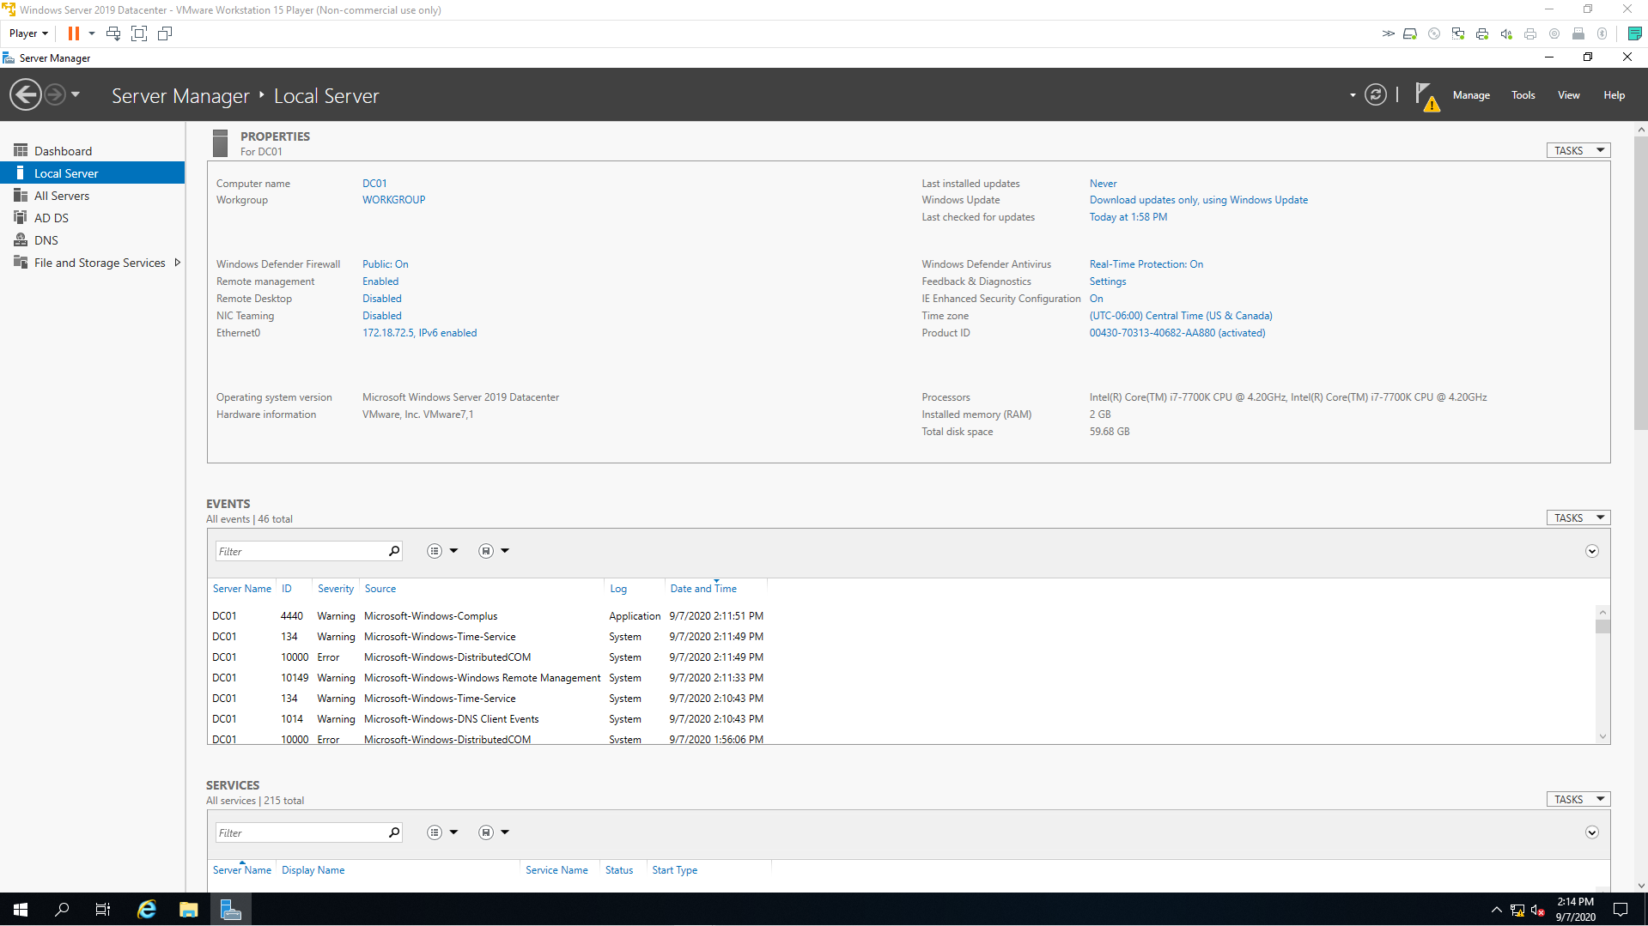

1. The wizard begins. Make sure the prerequisites are taken care of in full. If they are, click Next, otherwise take care of them first and then return.

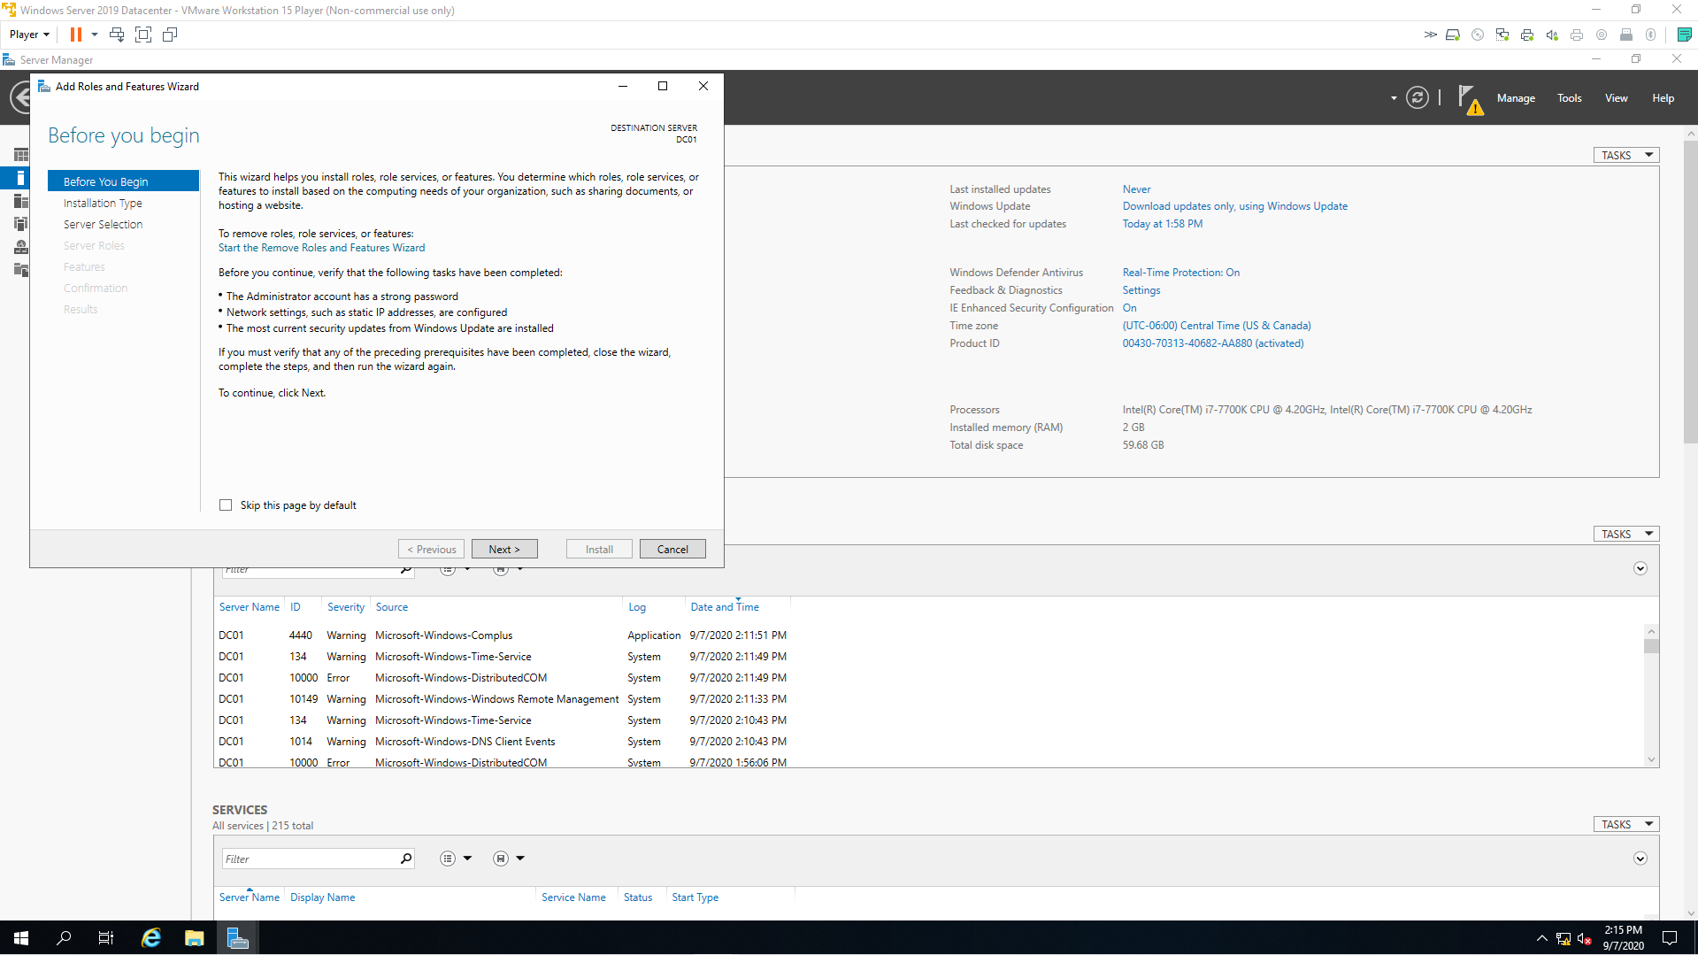

1. Keep the default radial box and click Next.

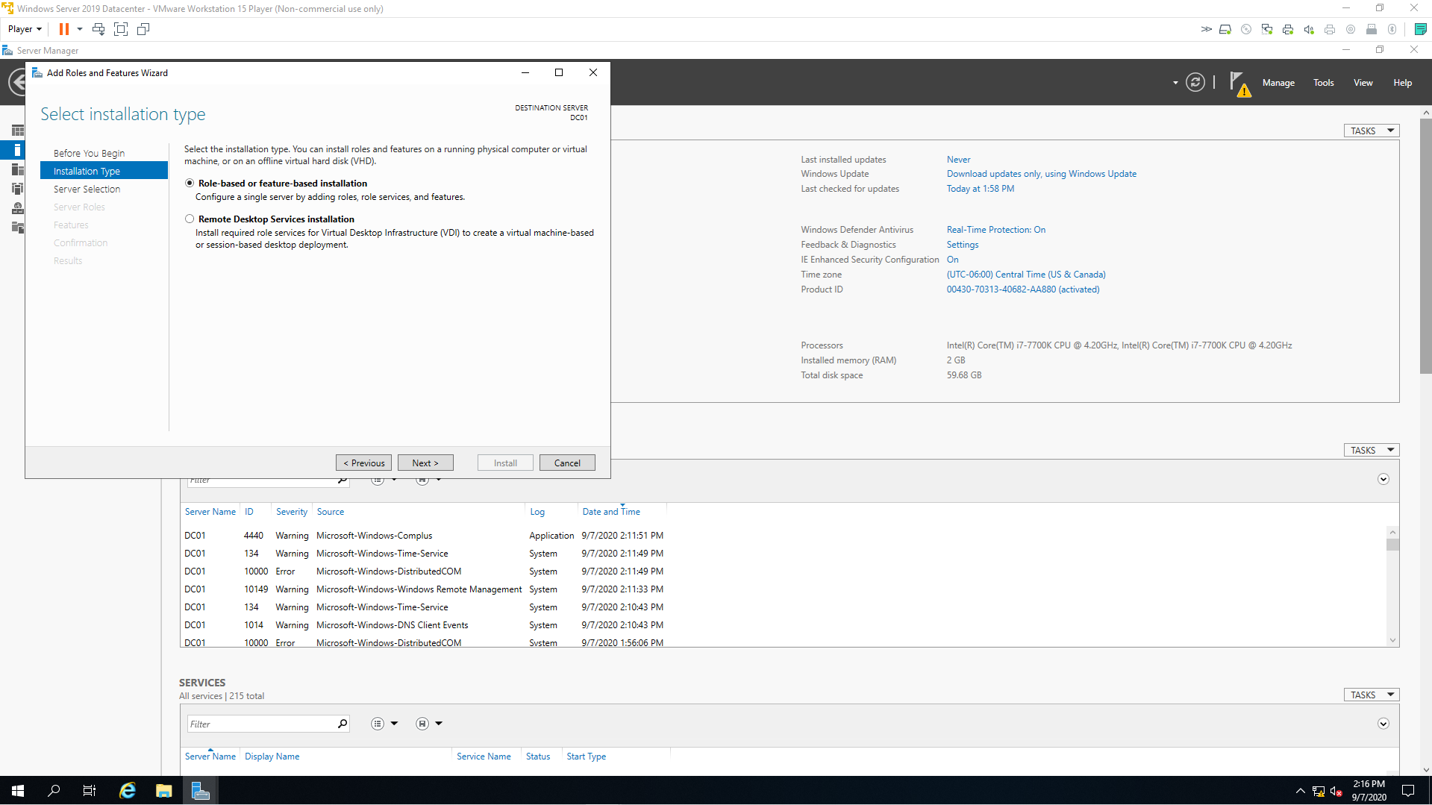

1. Keep the default selection of DC01. Click Next.

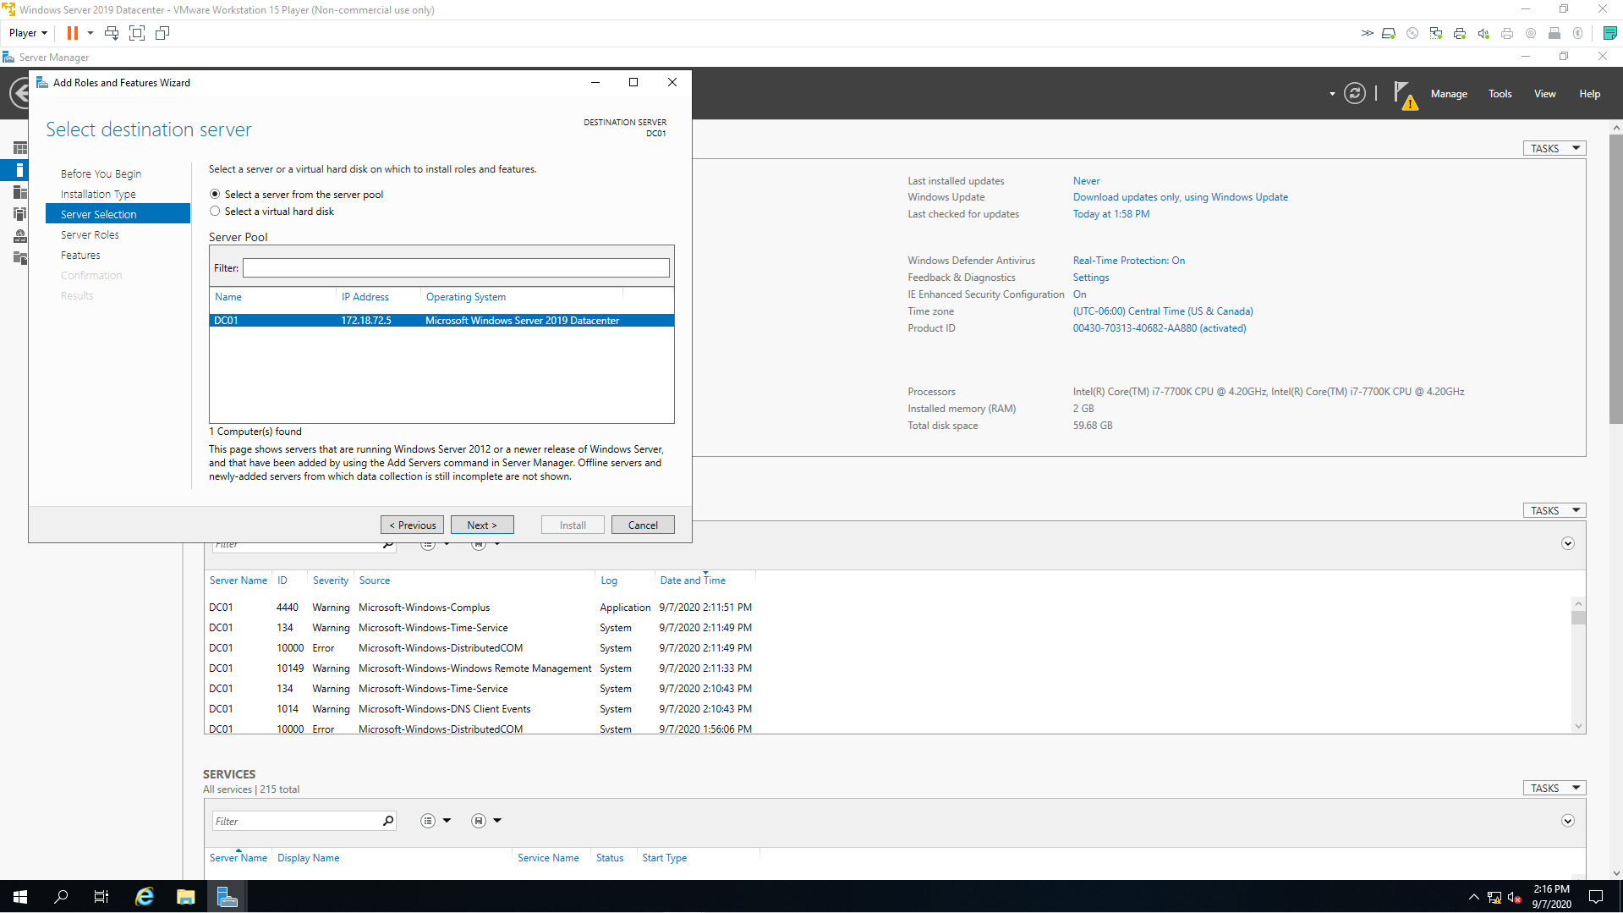

1. Click on active Directory Domain Services, Click Add Features on the pop-up box, then click DNS Server. Click Next.

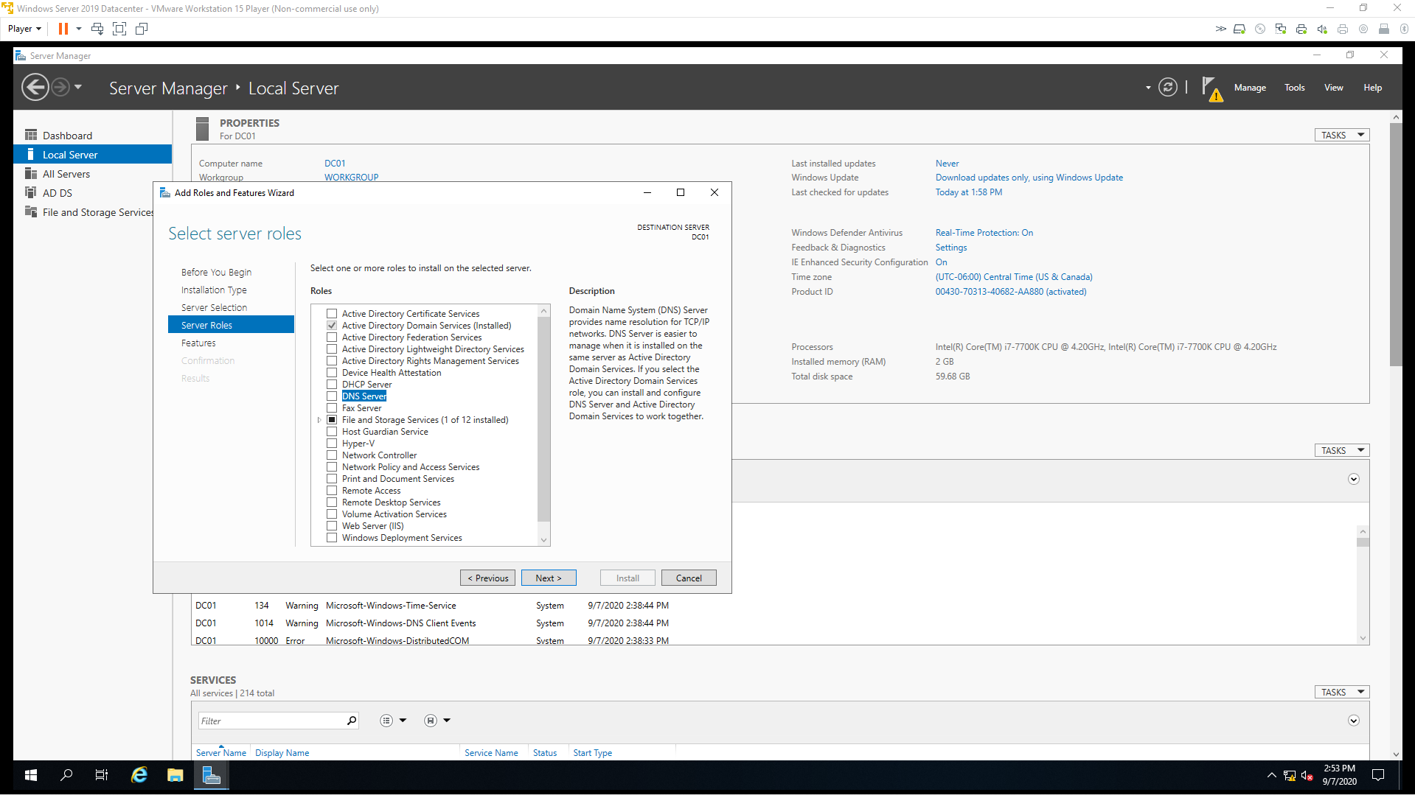

1. Click Add Features on the pop-up box.

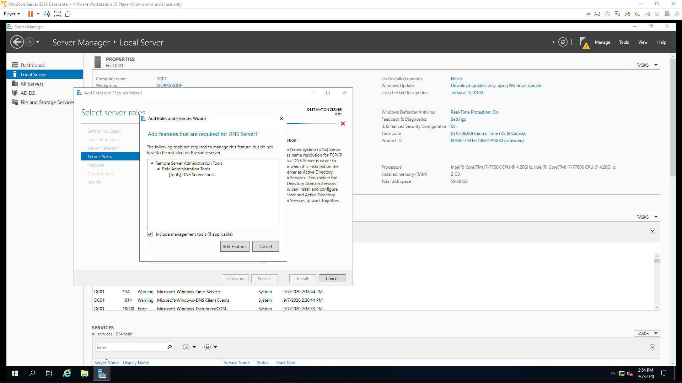

1. Click Next.

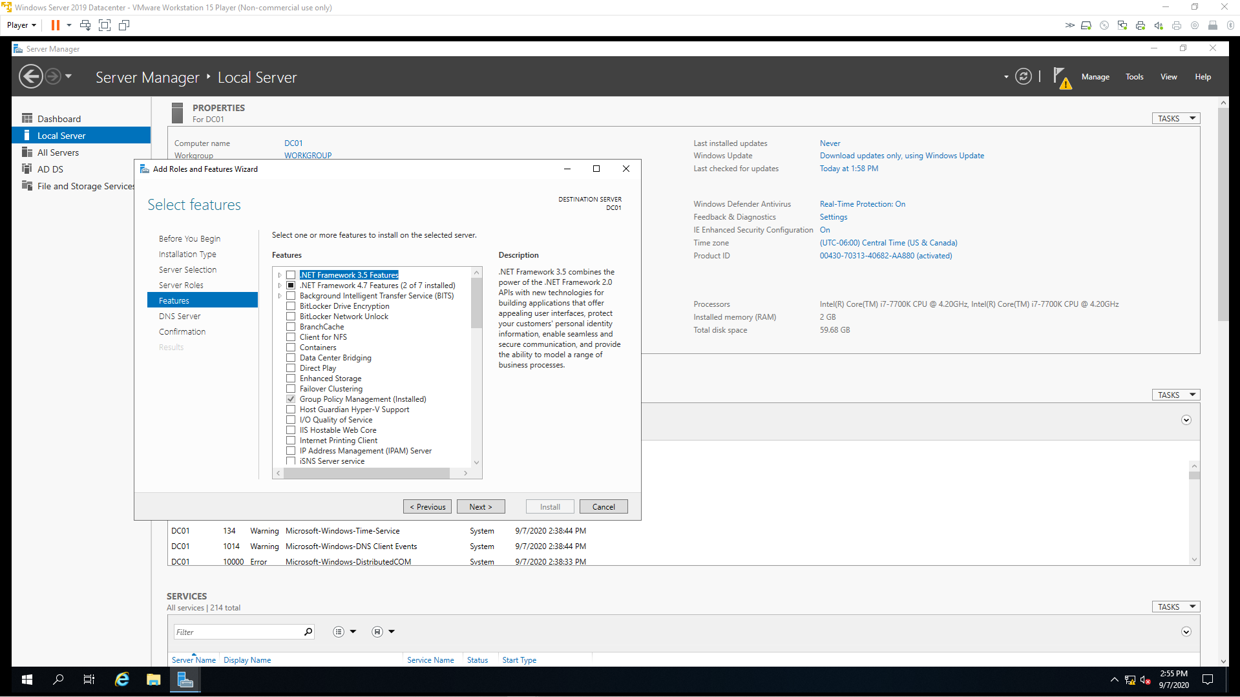

1. Click Next.

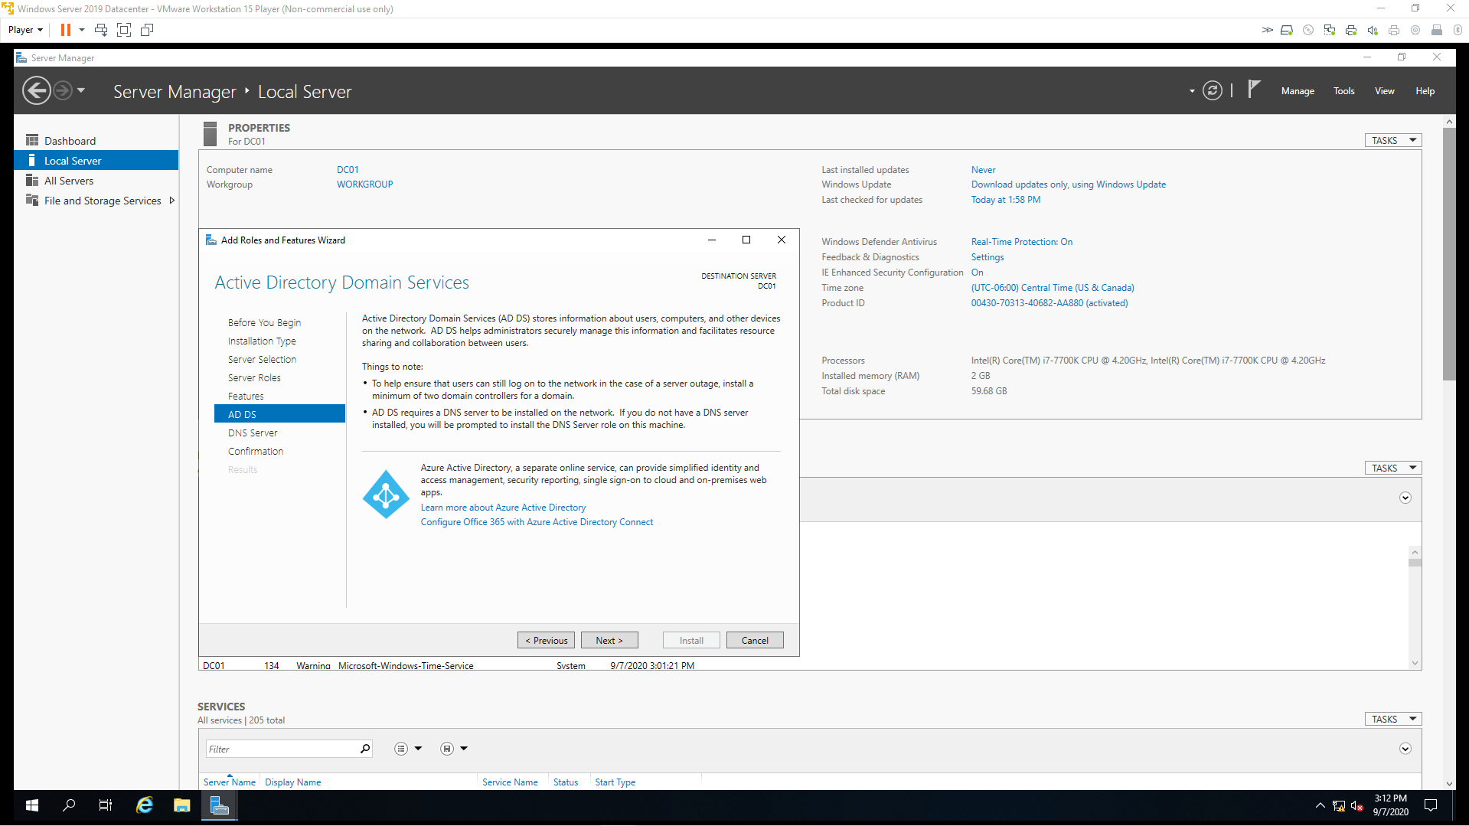

1. Click Next.

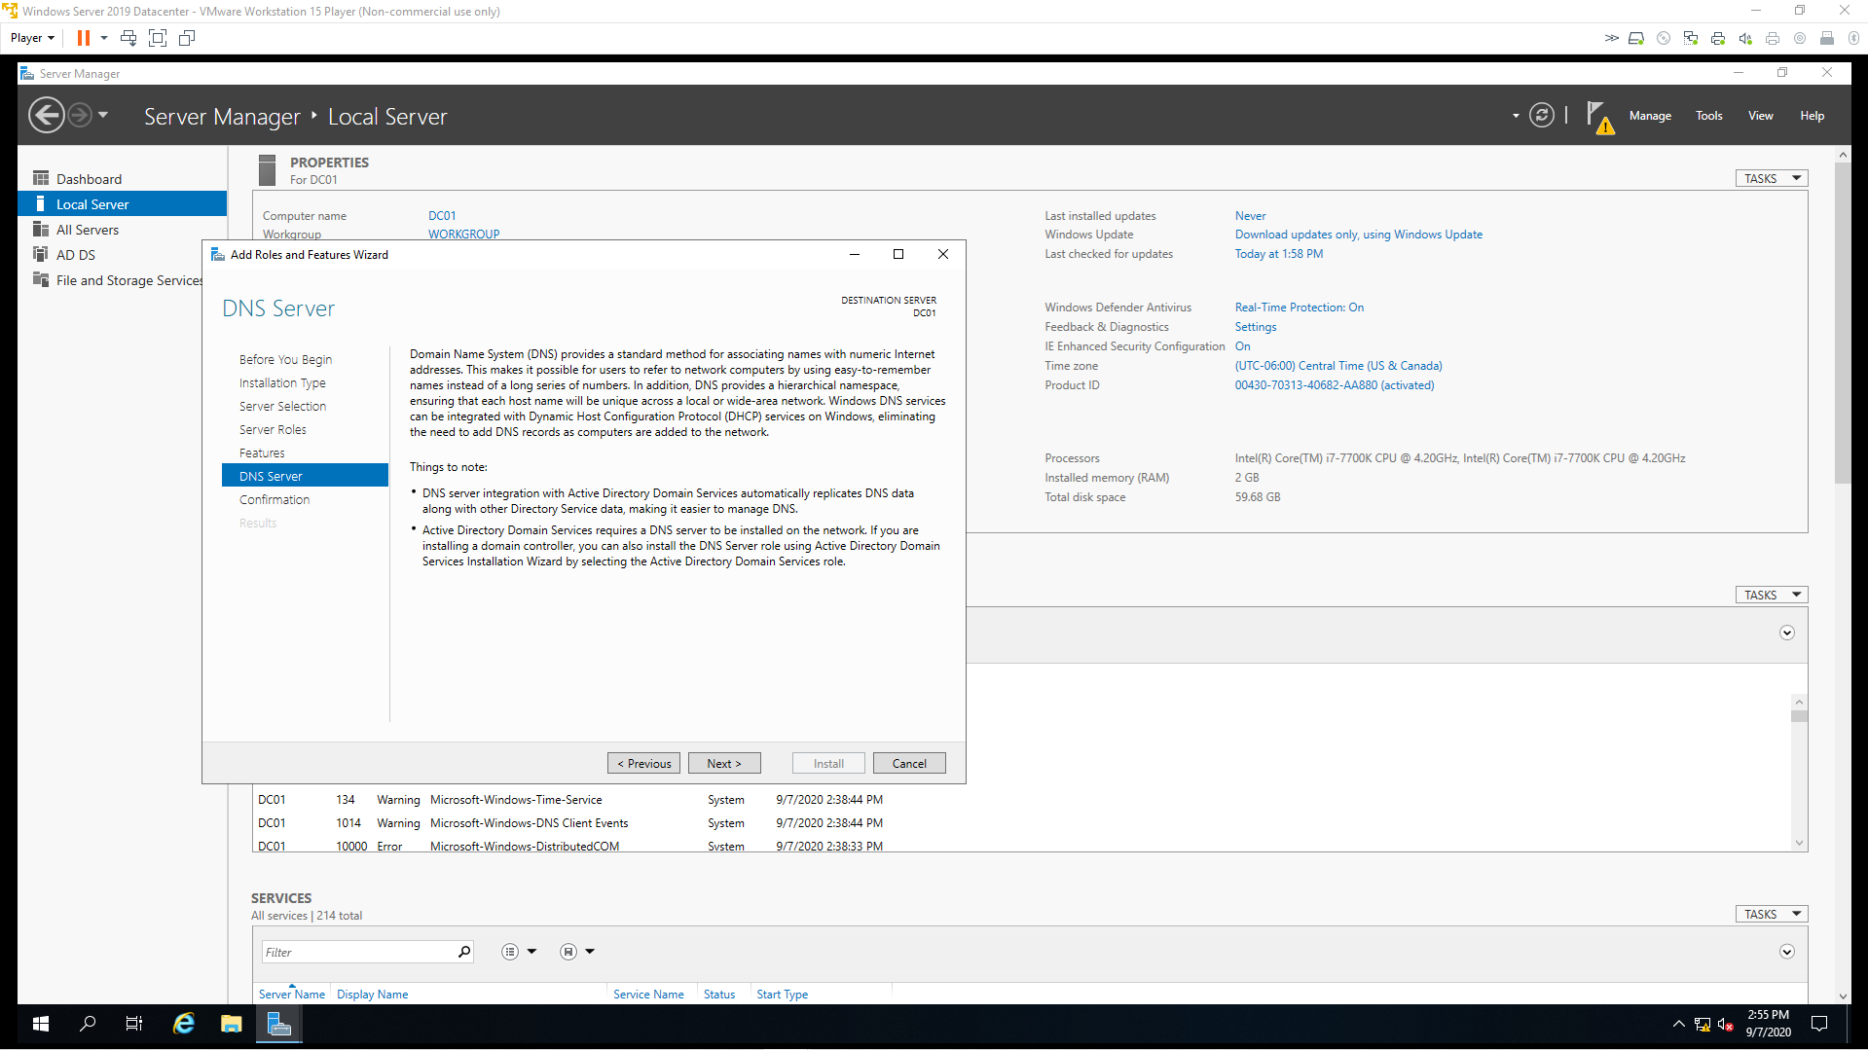

1. Confirm your selection. Click Install.

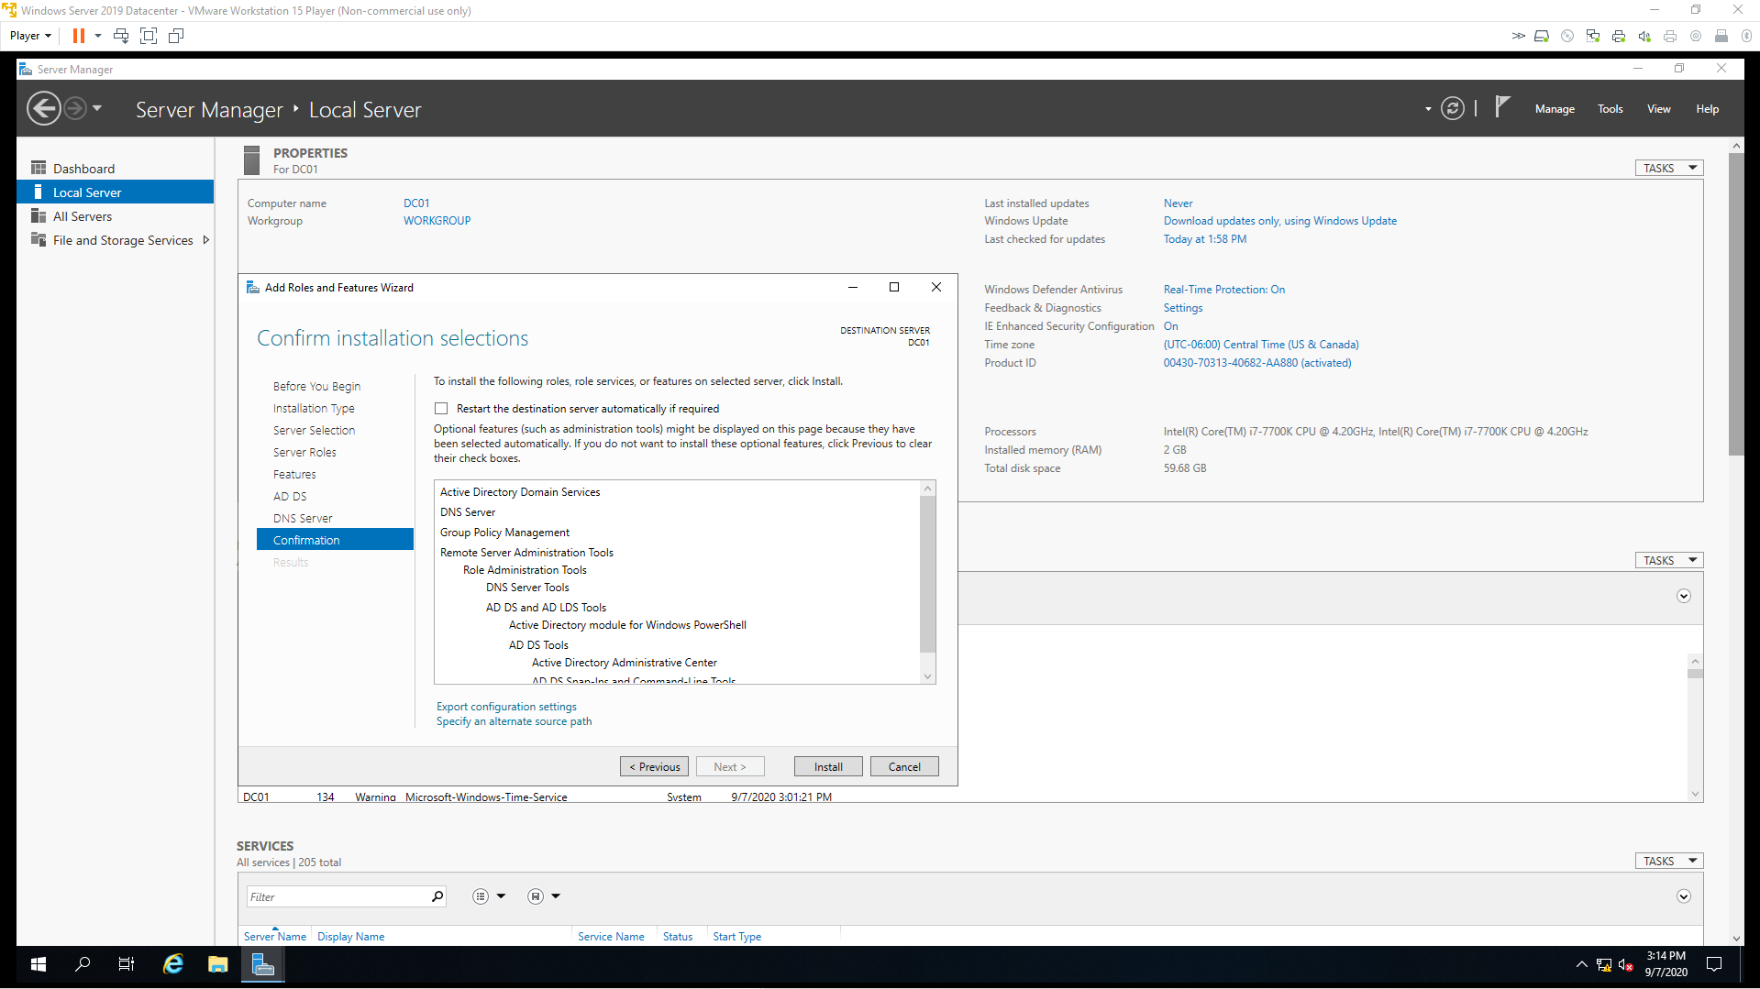

1. When the installation finishes, click on the blue font that says Promote the server to a domain controller.

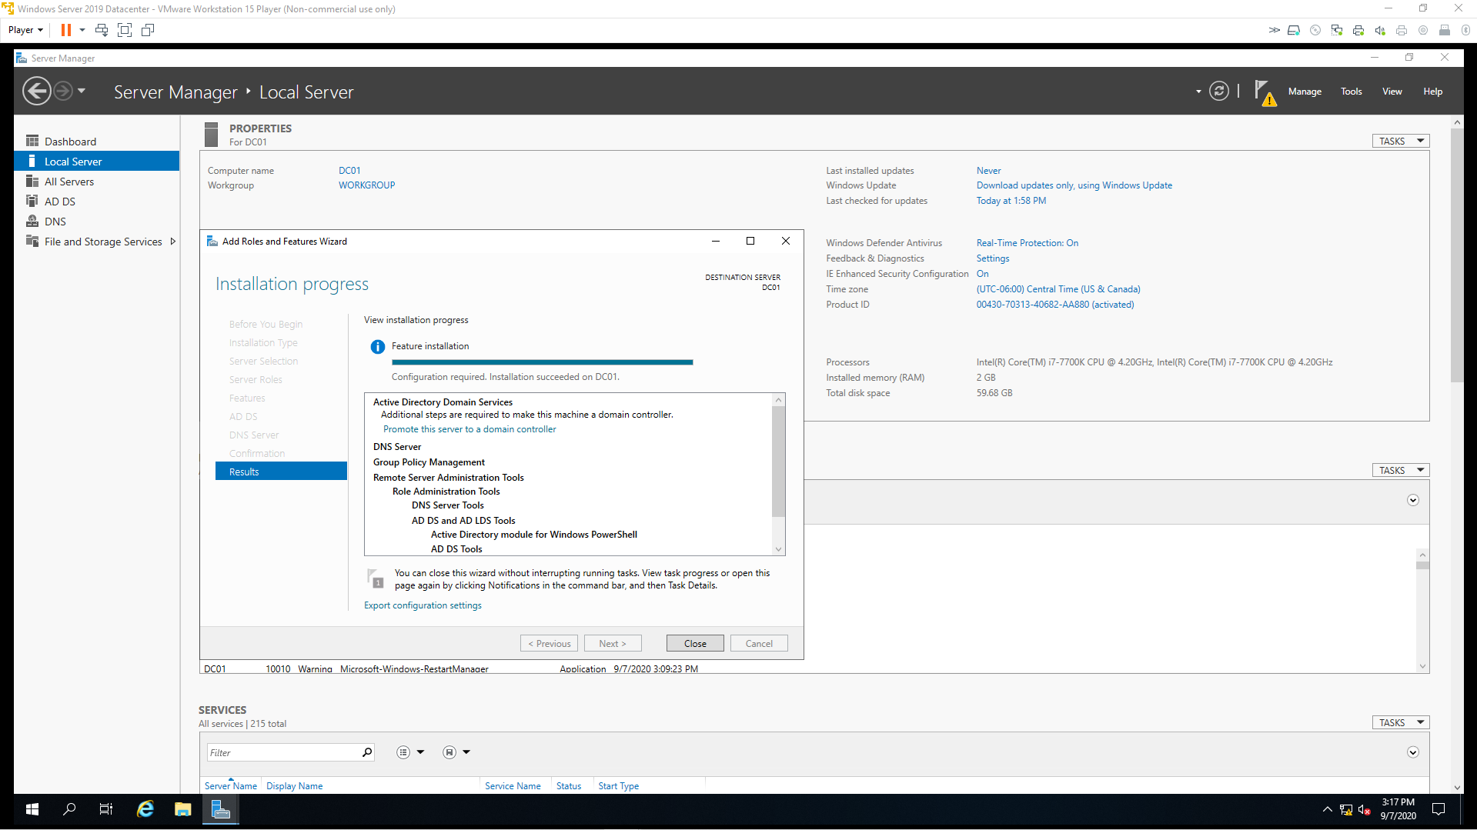

Step 2

1. Tick the Add a new forest radio button and enter your root domain name. Click Next.

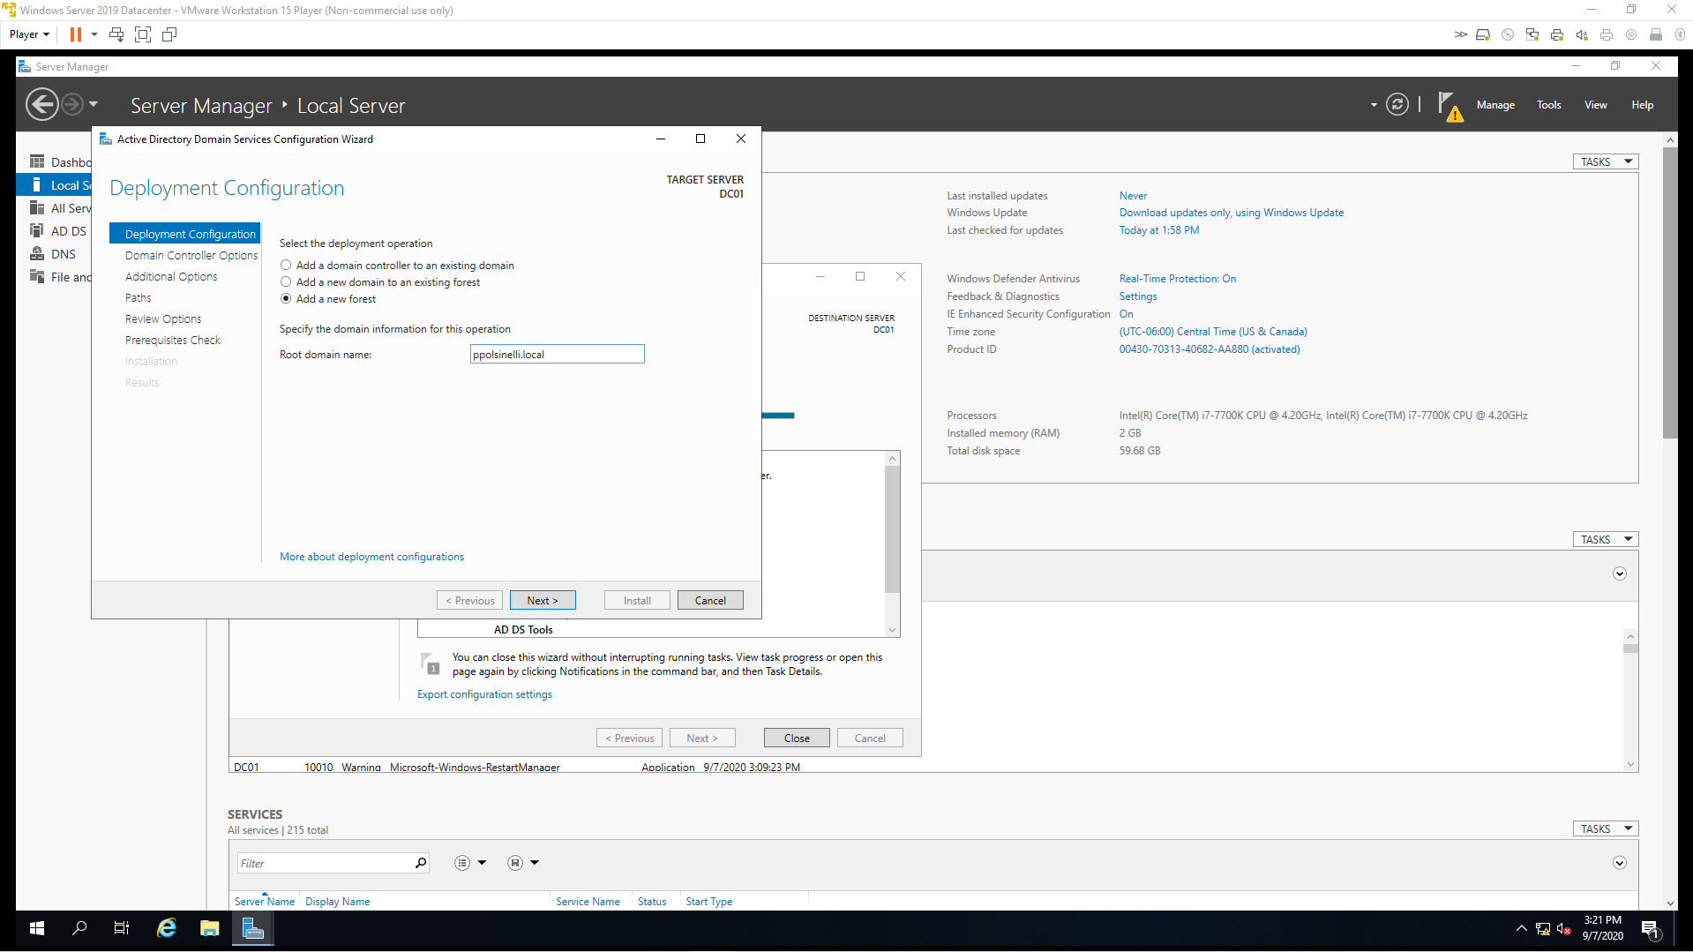

1. Leave the defaults, enter and confirm your password. Click Next.

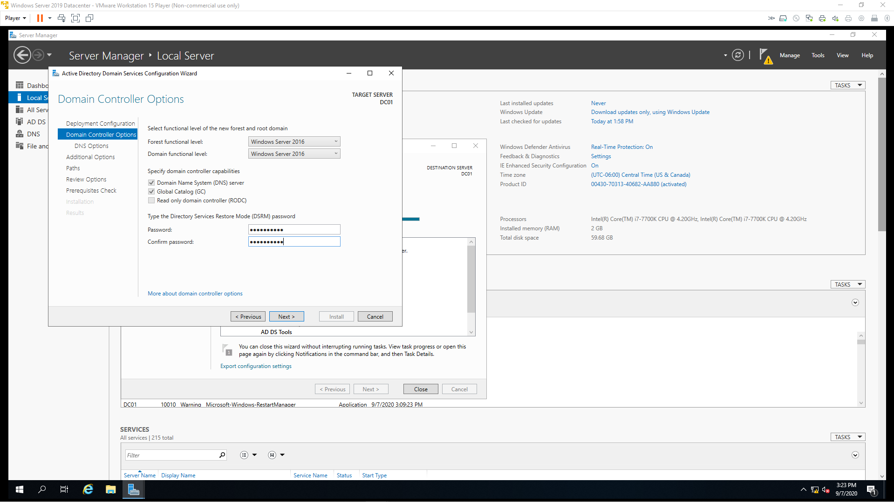

1. Ignore the warning. Leave defaults. Click Next.

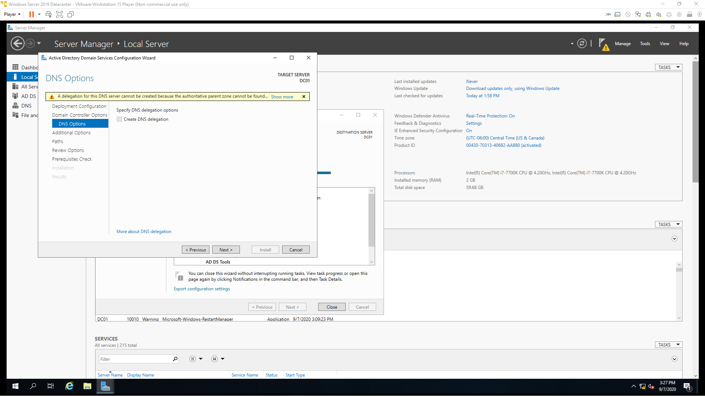

1. NetBIOS name will auto-populate. Leave the default. Click Next.

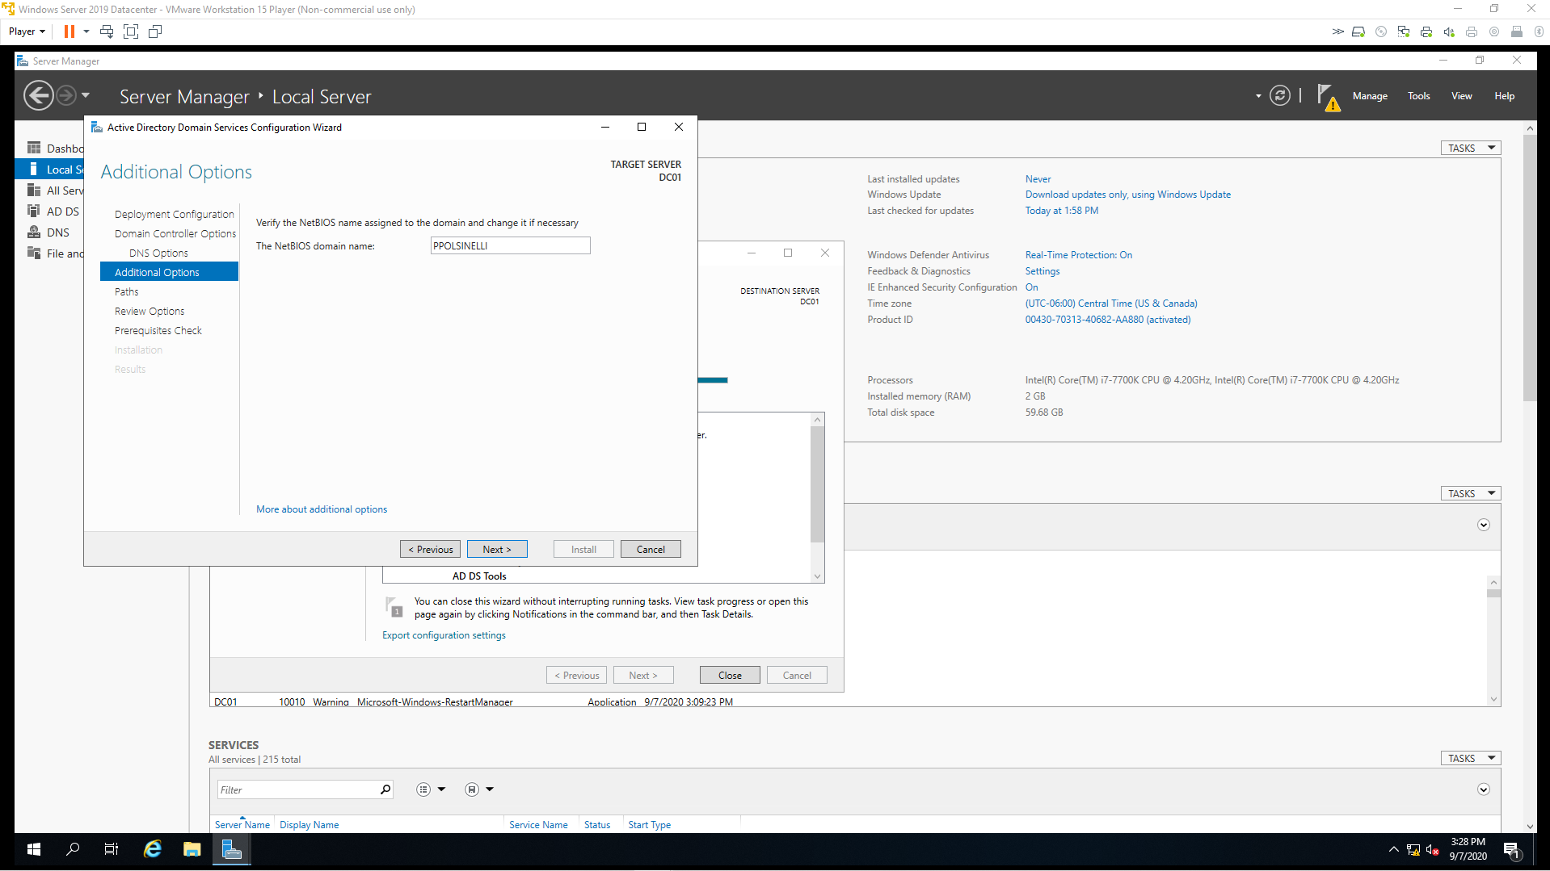

1. Leave defaults. Click Next.

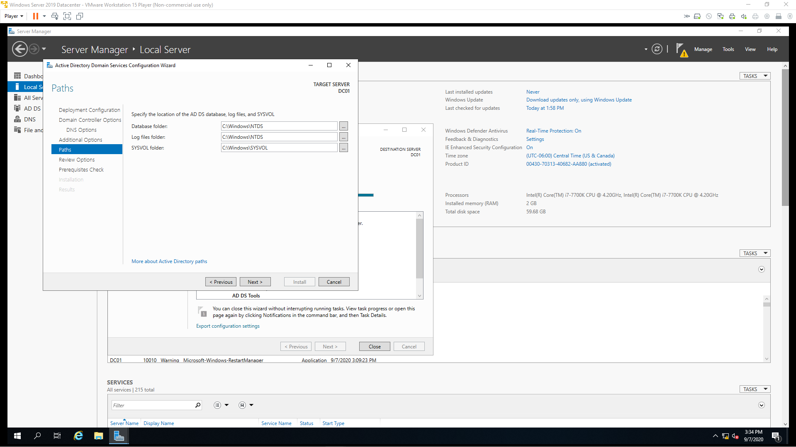

1. Click View script to see PowerShell script. Click Next.

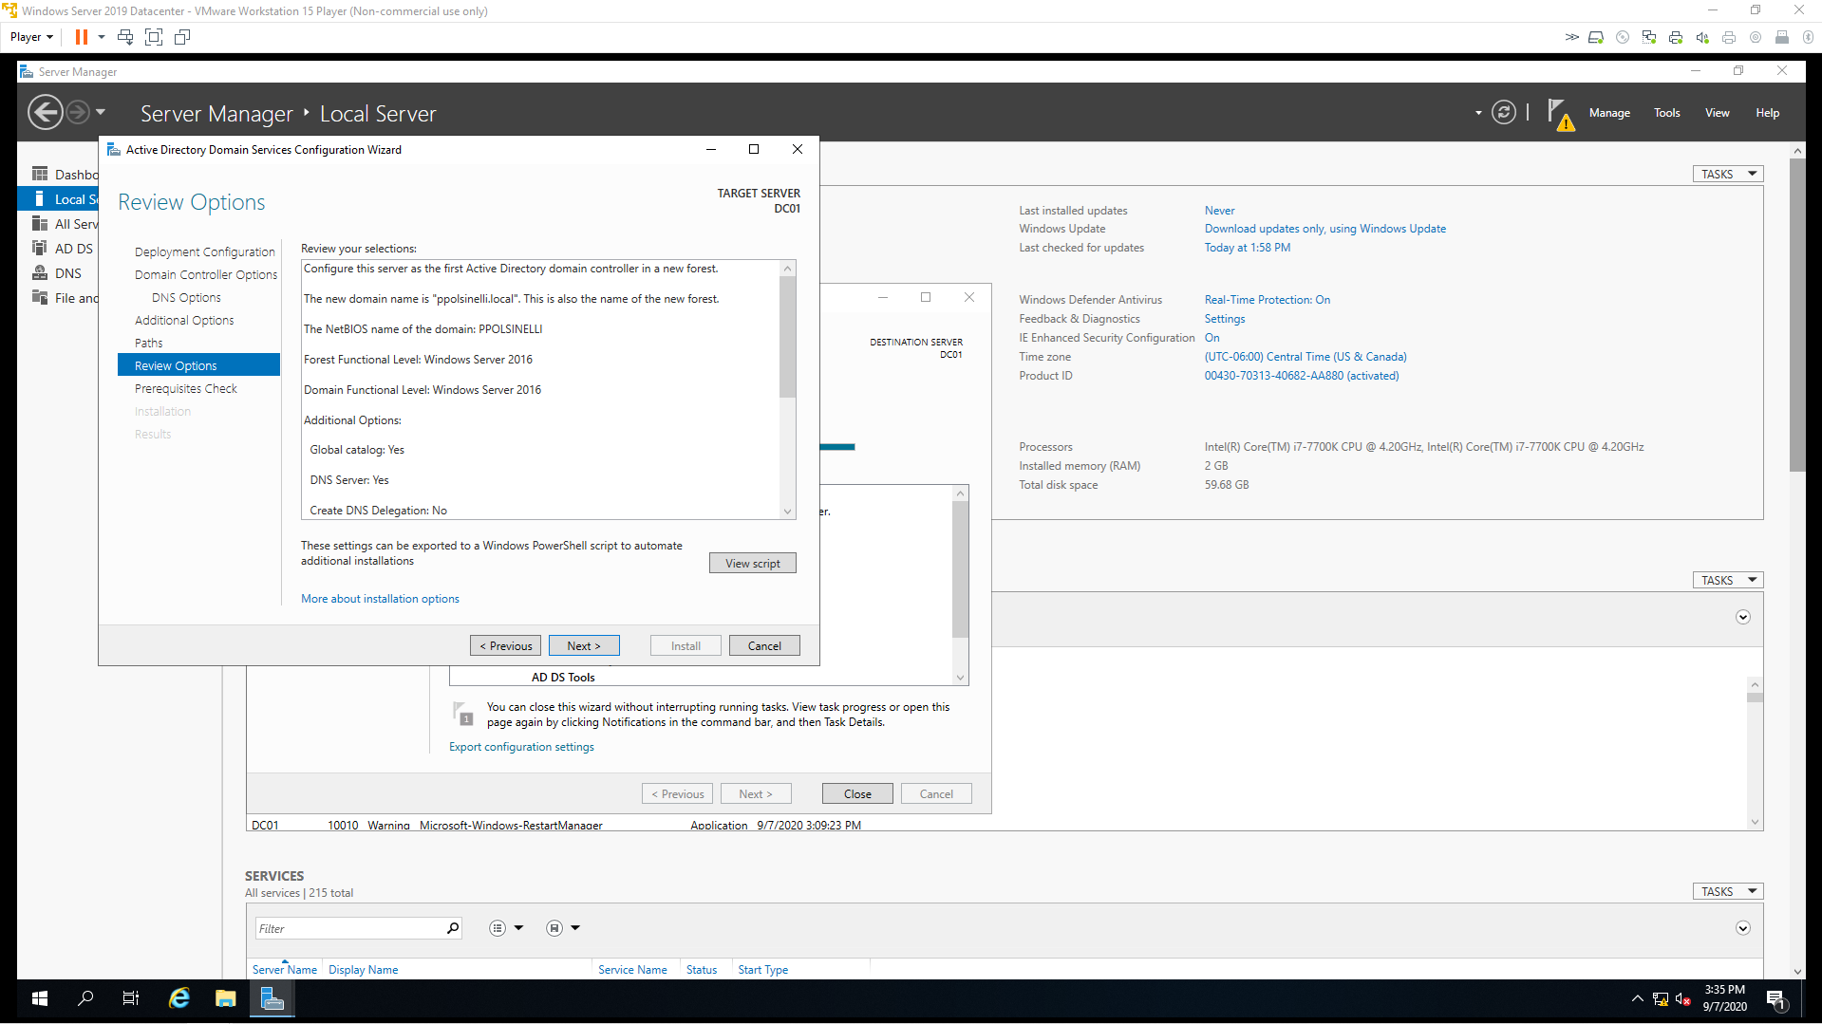

#

# Windows PowerShell script for AD DS Deployment

#

Import-Module ADDSDeployment

Install-ADDSForest `

-CreateDnsDelegation:$false `

-DatabasePath "C:\Windows\NTDS" `

-DomainMode "WinThreshold" `

-DomainName "ppolsinelli.local" `

-DomainNetbiosName "PPOLSINELLI" `

-ForestMode "WinThreshold" `

-InstallDns:$true `

-LogPath "C:\Windows\NTDS" `

-NoRebootOnCompletion:$false `

-SysvolPath "C:\Windows\SYSVOL" `

-Force:$true

1. Review and click Install.

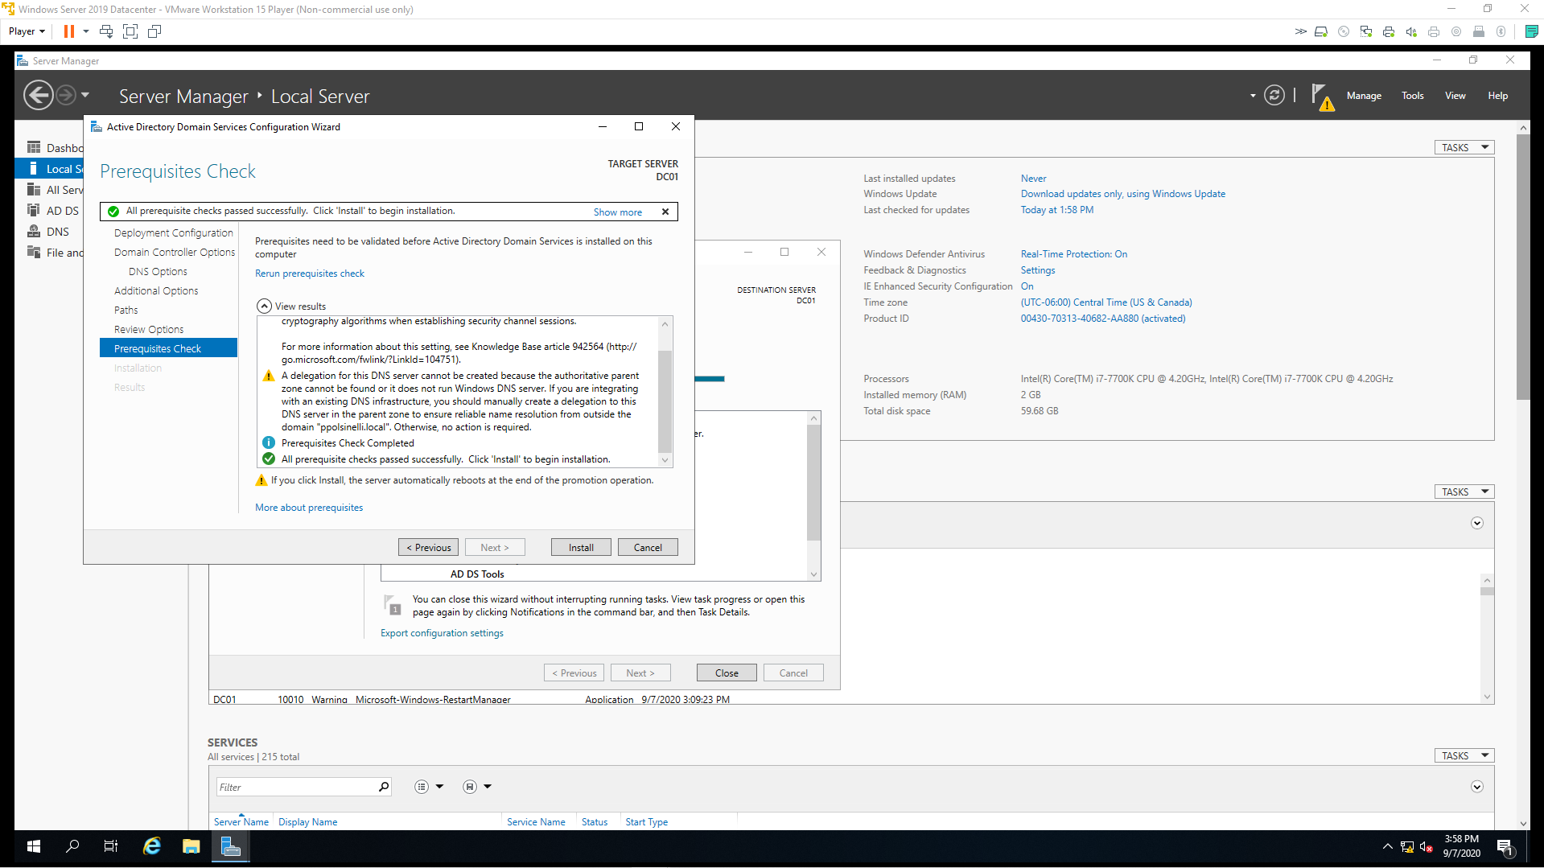

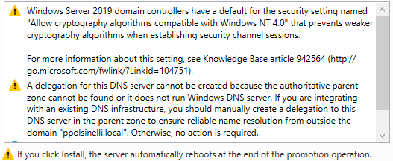

According to the Microsoft article on the first warning, there are several approaches to work around the issues caused by this (*The Net Logon Service on Windows Server 2008 and Newer Domain Controllers Do Not Allow the Use of Older Cryptography Algorithms That Are Compatible with Windows NT 4.0 by Default*, 2018). The best in my opinion is to get and install the software updates either from the official site or trusted 3rd party vendors.

The second warning seems like it can just be ignored if you’re not integrating with an existing DNS infrastructure. Solutions to the issue vary among circumstance (*Windows - A Delegation For This DNS Server Cannot Be Created*, n.d.). I would recommend ignoring it completely if possible or following some solutions in the web article depending on the circumstances.

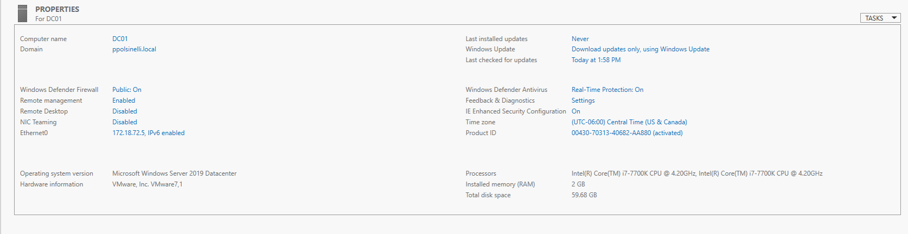

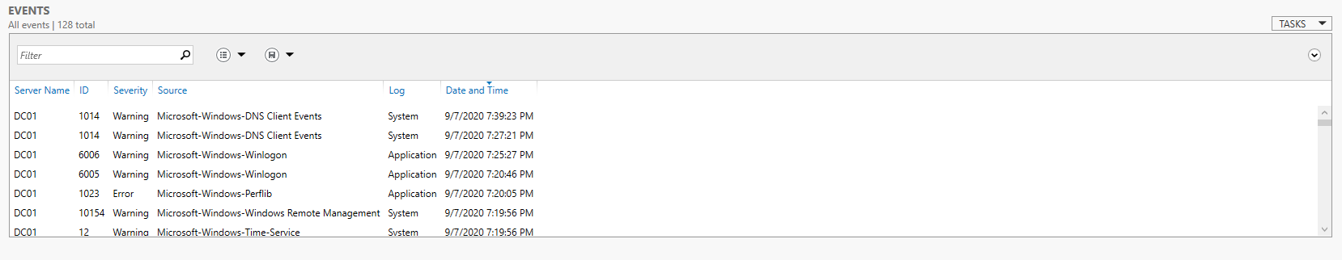

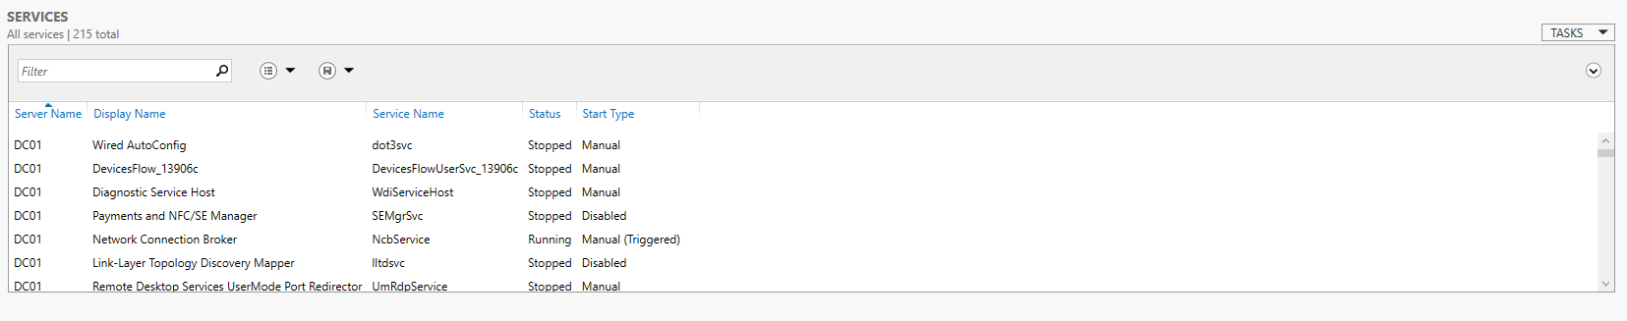

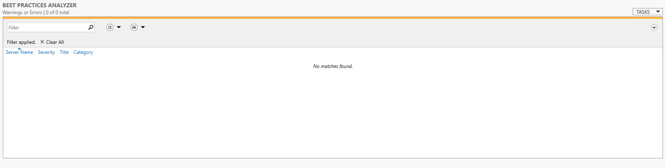

References

*The Net Logon service on Windows Server 2008 and newer domain controllers do not allow the use of older cryptography algorithms that are compatible with Windows NT 4.0 by default*. (2018, April 17). Microsoft. <https://support.microsoft.com/en-us/help/942564/the-net-logon-service-on-windows-server-2008-and-newer-domain-controll>

*Windows - A Delegation For This DNS Server Cannot Be Created*. (n.d.). PeteNetLive. Retrieved September 7, 2020, from https://www.petenetlive.com/KB/Article/0001287